PS Lab sheet 6

IT24100257 Wickaramasinghe G.K.S

1) X = number of students who passed the test out of 50 students

P = 0.85 , n = 50

i) Binomial distribution

ii)

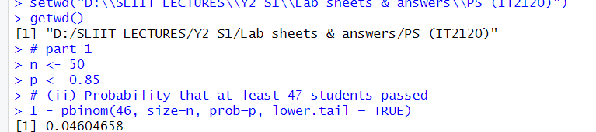

2)

i) x = number of calls per hour

ii) x ~ Poisson (Lamda = 12)

iii)

